**Mini Project Report on**



**Human Gesture Recognition**



**Submitted in partial fulfilment of the requirement for the award of the degree of**

**BACHELOR OF TECHNOLOGY**

**IN**

**COMPUTER SCIENCE & ENGINEERING**

**Submitted by:**

**Student Name : Karunesh Gupta** **University Roll No.2016815**

***Under the Mentorship of***

**Dr. Parul Madan**

**Associate Professor**



**Department of Computer Science and Engineering**

**Graphic Era (Deemed to be University)**

**Dehradun, Uttarakhand**

**July-2023**



**CANDIDATE’S DECLARATION**

I hereby certify that the work which is being presented in the project report entitled **“Human Gesture Recognition”** in partial fulfillment of the requirements for the award of the Degree of Bachelor of Technology in Computer Science and Engineeringof the Graphic Era (Deemed to be University), Dehradun shall be carried out by the under the mentorship of **Dr. Parul Madan, Associate Professor**, Department of Computer Science and Engineering, Graphic Era (Deemed to be University), Dehradun.

Name: Karunesh Gupta University Roll no. : 2016815

**Table of Contents**

|  |  |  |
| --- | --- | --- |
| **Chapter No.** | **Description** | **Page No.** |
| Chapter 1 | Introduction | **1,2** |
| Chapter 2 | Literature Survey | **3,4** |
| Chapter 3 | Methodology | **5,6,7** |
| Chapter 4 | Result and Discussion | **8** |
| Chapter 5 | Conclusion and Future Work | **9** |
|  | References | **10** |

**Chapter 1**

**Introduction**

* 1. **Introduction**

A Our primary objective is to develop a system that can accurately interpret hand movements and recognize the corresponding ASL gestures and English alphabet signs. By utilizing computer vision techniques and machine learning algorithms, we can analyze the positions and movements of the user's hand in real-time, extracting meaningful features that differentiate different gestures.

Our primary objective is to develop a system that can accurately interpret hand movements and recognize the corresponding ASL gestures and English alphabet signs. By utilizing computer vision techniques and machine learning algorithms, we can analyze the positions and movements of the user's hand in real-time, extracting meaningful features that differentiate different gestures .

Here we used Google Mediapipe framework which gives us plenty prebuilt models to classify our movements. MediaPipe is a Framework for building machine learning pipelines for processing time-series data like video, audio, etc. This cross-platform Framework works on Desktop/Server, Android, iOS, and embedded devices like Raspberry Pi Moreover it provides a comprehensive solution for building real-time applications involving perception tasks, such as hand tracking and pose estimation. Mediapipe offers a robust set of pre-trained models and pipelines, making it an ideal choice for our gesture recognition project.

Solutions are open-source pre-built examples based on a specific pre-trained TensorFlow or TFLite model.

The project involves several key steps. First, we borrowed Mediapipe's hand tracking capabilities to detect and track the user's hand in a video stream or webcam feed. This provides us with the necessary data to analyze the hand's shape and motion. Next, we apply machine learning techniques to train a model that can classify these hand gestures.

To train our gesture recognition model, we utilize a labelled dataset consisting of a diverse range of hand gesture samples, including ASL gestures and English alphabet signs. We extract relevant features from the hand tracking data, such as finger positions, palm orientation, and movement trajectories. These features serve as inputs to our machine learning model, which learns to associate them with specific gestures.

Once our model is trained, we integrate it into a real-time application, enabling users to interact with the system by performing ASL hand gestures or English alphabet signs in front of a camera. The application captures the live video feed, processes it using the trained model, and produces the corresponding recognized gesture as an output.

According to this motivation we can help those with impaired visions and disabilities to a much broader boundaries and can help the humanity with the advanced technology.

[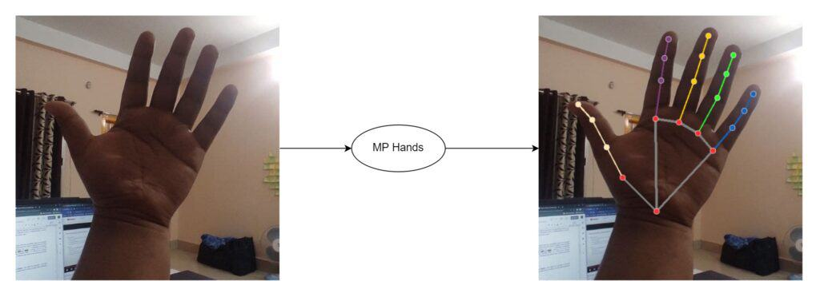](https://learnopencv.com/wp-content/uploads/2022/02/mediapipe-series-hands-solutions.jpg)

Figure1.1 : hand landmarks rendered on the images using MediaPipe

By recognizing ASL hand gestures and English alphabet signs, our project aims to facilitate communication between individuals who use sign language and those who are unfamiliar with it. This technology can be used in various applications, such as educational tools, assistive devices for the hearing impaired, or even as a means of improving accessibility in everyday situations.

In conclusion, our project combines the power of MediaPipe and machine learning techniques to recognize ASL hand gestures and English alphabet signs. By leveraging computer vision and real-time analysis, we aim to develop a system that can bridge the communication gap between sign language users

**Chapter 2**

**Literature Survey**

The hand gesture system is used been more in now a days because it helps in the interaction between the humans and machine. Hand Recognition in the class human recognition gives more meaningful information when compared to the other type of gestures. The principal component of the hand gesture recognition system includes segmentation and tracking hand from the background and then the feature is extracted from the segmented hand image using various algorithms and finally we are going to recognize the hand gestures. Hand gesture recognition is used in many applications like- HCI, robotics, sign language, digit and alphanumeric value.

Gestures are expressive, meaningful body motions involving physical movements of the fingers, hands, arms, head, face, or body. There are many kinds of expressions of human movements, the common one is the expression of gestures. In other words, Gesture is non-vocal way of communication which uses hand motion, different postures of body, face expressions. Gesture recognition based on computer vision has gradually become a hot research direction in the field of human-computer interaction.

**Few Studies**

Sourav Bhowmick, Sushant Kumar, and Anurag Kumar [2] introduced a technique to recognize ASL gestures using Deep Learning for two-letter combinations. The drawback of this method is that this technique uses still images and it will be difficult to track gestures with a motion. Gestures that contain motion are not recognized accurately.

Onamon Pinsanoh, Yuttana Kitjaidure, Ariya Thongtawee [3] used a technique to find the gestures by dividing the frame into left and right sides. But this process increases the complexity of gesture feature extraction.

**Hand sign language recognition using ASL**

The National Institute on Deafness and Other Communications Disorders (NIDCD) points out that the 200-year-old American Sign Language is a complete, complex language but is the main language for most North American deaf people. Too much will help deaf people develop sign language action systems and the aggregation of people using modern technology.

In this category, only hand features are used to sign language recognition. There are some important sub-areas for hand sign language recognition which are: hand detection, hand pose estimation, real-time hand tracking, hand gesture recognition, and hand pose recovery.

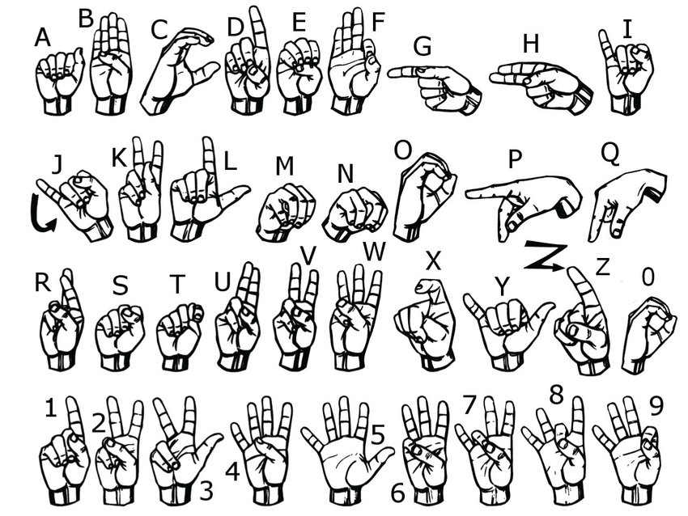

Figure1.2 American Sign Language

**Chapter 3**

**Methodology**

**3.1 Data collection**

The proposed system recognizes the American sign language of alphabets. It recognizes gestures with motion and gestures without motion as well. The first step is to collect the dataset for the system MediaPipe hands is a high- fidelity hand and finger tracking framework used in the dataset preparation. It makes use of several ML models to infer the 21 three dimensional landmarks of a hand in real time from just one frame.   
The custom-built segmented dataset for instance contains 9 Classes from A to F and 3 more classes Love, Rock , thumbsup where each class contains approximately 300 images . Although the number of classes can be extended according to the user’s choice but due to the System’s hardware constraint (GPU) we restricted it to 9 classes only.

The images are captured and the extraction of the region of interest (Hand) is done while collecting dataset which proved beneficial in further step of classification by the model built using leveraging the functionalities given by Google MediaPipe and the hand extracted images are overlaid on a white background image of 300 X 300 pixels in the center so that all the frames extracted should have equal distribution horizontally and vertically.

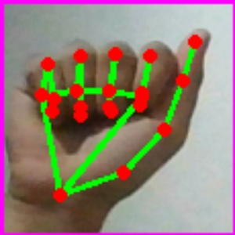 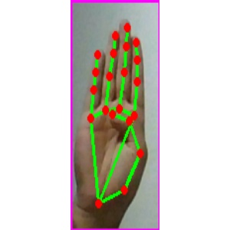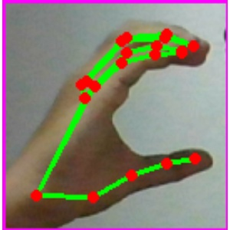 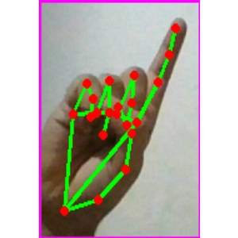 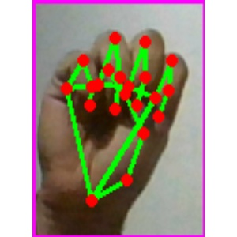 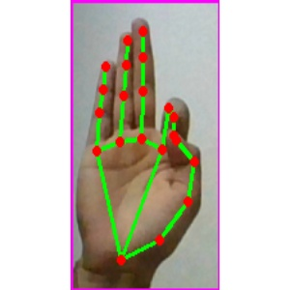

A B C D E F

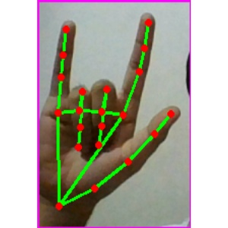 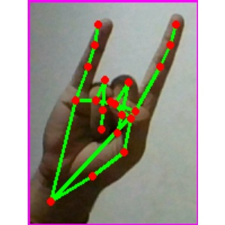 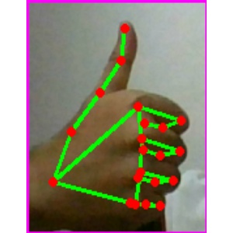

Love Rock Thumbsup

**3.2 System architecture**

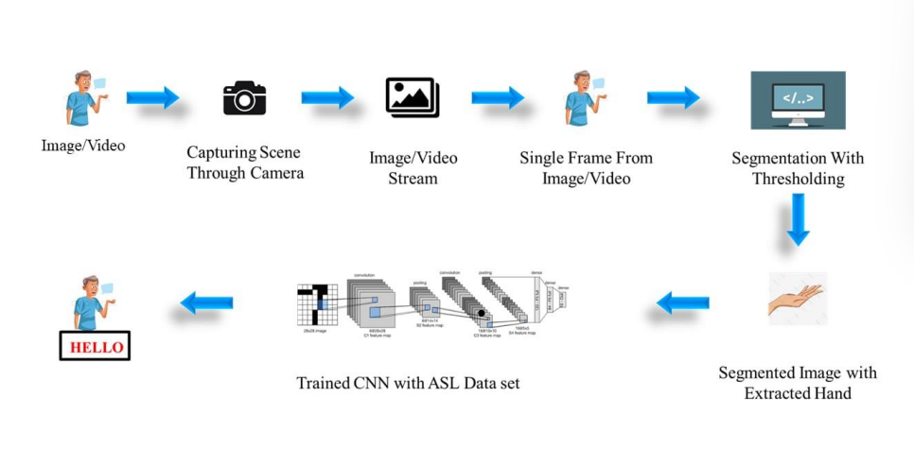

The training is done by Classification Module Based on Teachable Machine on web browser

* 1. **Libraries Used**

**1. OPENCV**: It is a cross-platform library using which we can develop real-time computer vision applications.

* It mainly focuses on image processing, video capture and analysis including feature like face detection and object detection.
* Opencv Algorithms can be used to detect and recognize faces, identify objects, classify human actions in videos, track camera movements, track moving objects, extract 3D models of objects, produce 3D point clouds from stereo cameras, stitch images together to produce a high resolution image of an entire scene,etc.

**2.NUMPY**: NumPy is a Python library used for working with n-dimensional arrays.In Python we have lists that serve the purpose of arrays, but they are

slow to process. NumPy aims to provide an array object that is up to 50x faster than traditional Python lists as NumPy arrays are stored at one continuous place in memory unlike lists.

**3.KERAS**: Keras is a deep learning API written in Python, running on top of the machine learning platform TensorFlow. It was developed with a focus on enabling fast experimentation. The core data structures of Keras are layers and models. The simplest type of model is the Sequential model, a linear stack of layers. Keras contains numerous implementations of commonly used neural network building blocks such as layers, objectives, activation functions, optimizers.

**4. Tensorflow :** TensorFlow is an open-source software library that provides a framework for building and deploying machine learning models. TensorFlow is a powerful tool that helps you create and train models to make predictions or perform tasks based on data.

With TensorFlow, you can create complex neural network models, which are a type of machine learning model inspired by the human brain. Neural networks consist of interconnected layers of artificial neurons, and they are particularly good at learning patterns and making predictions from large amounts of data.

Once defined and trained TensorFlow model is built ,we can use it to make predictions on new, unseen data. TensorFlow provides tools for deploying models in various environments, such as mobile devices, web applications, or cloud platforms.

**5. CVZONE :** This is a Computer vision package that makes it’s easy to run Image processing and AI functions. At the core it uses OpenCV and mediapipe libraries

**Chapter 4**

**Result and Discussion**

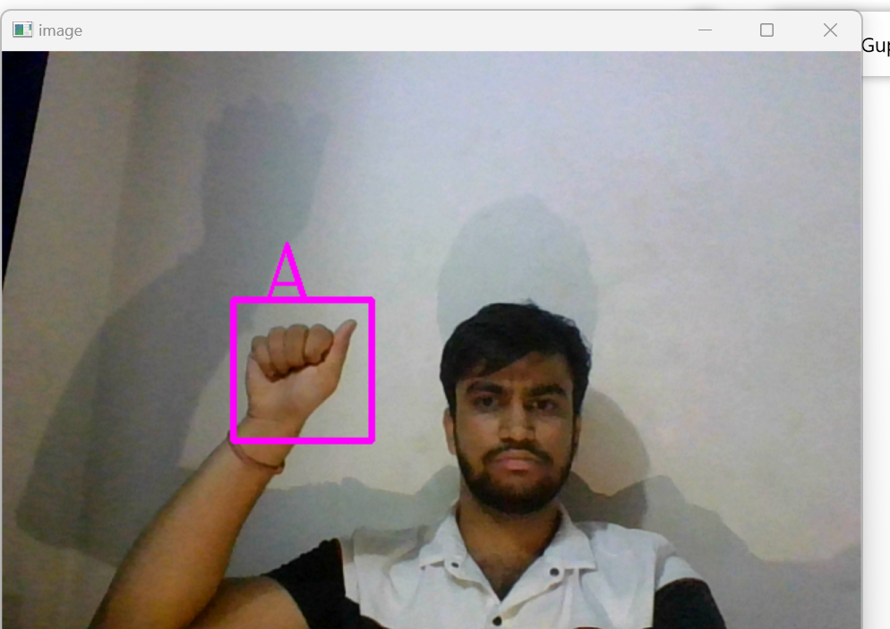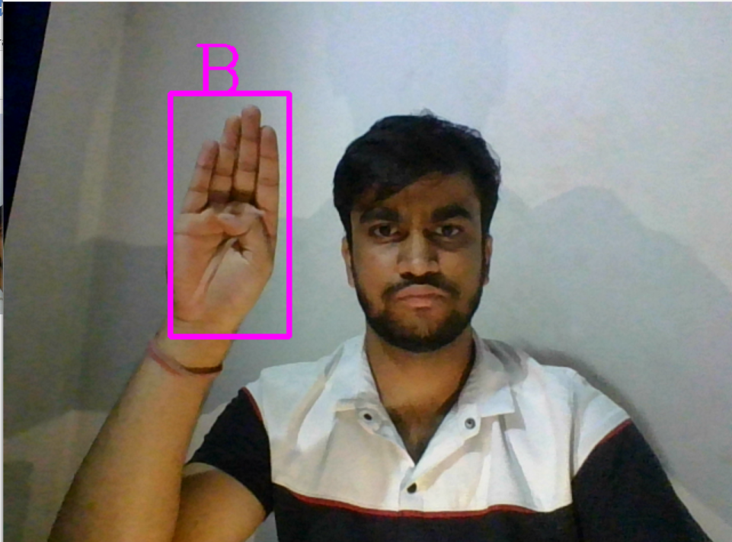 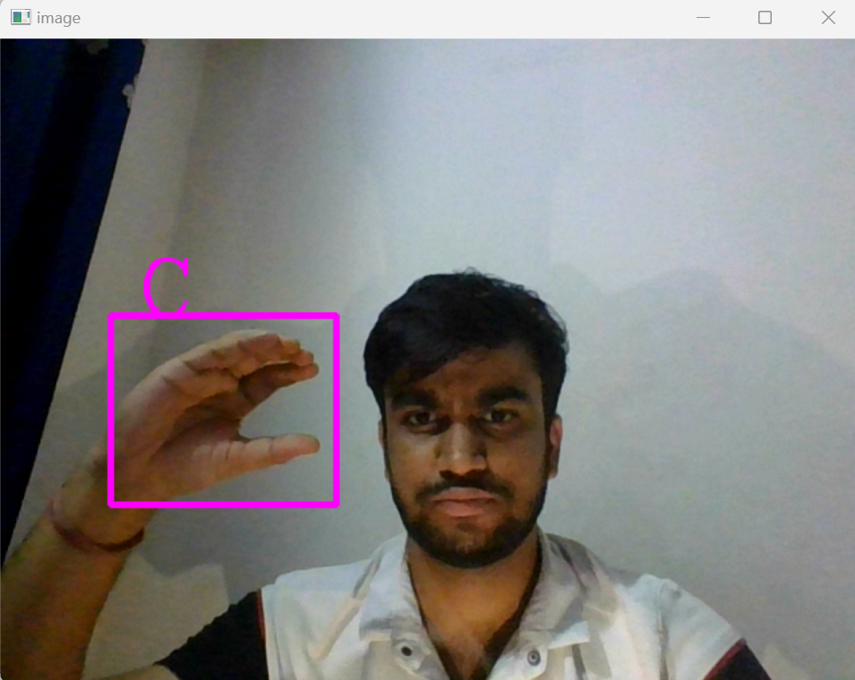

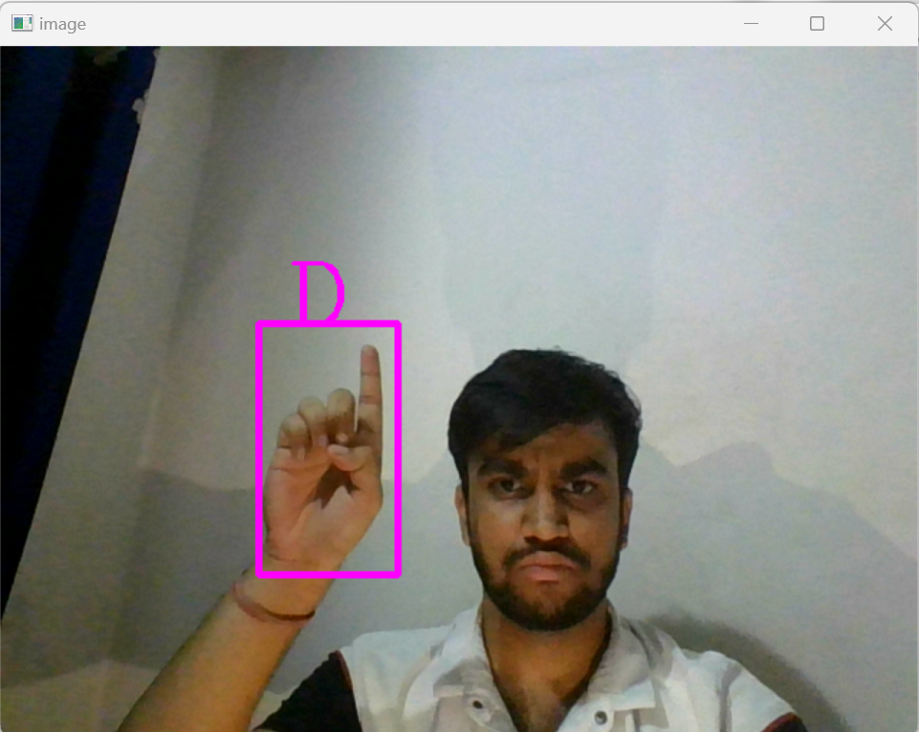 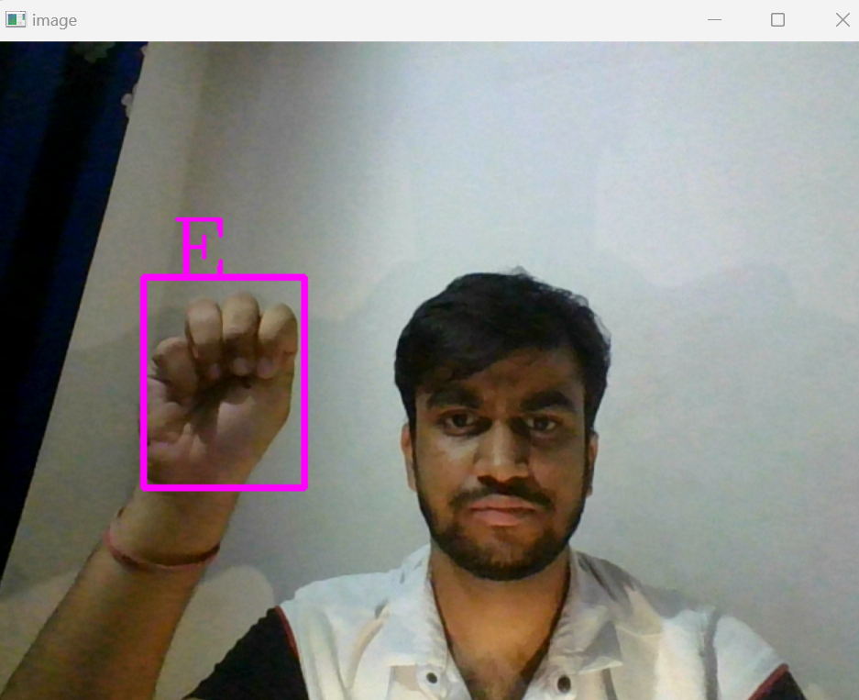 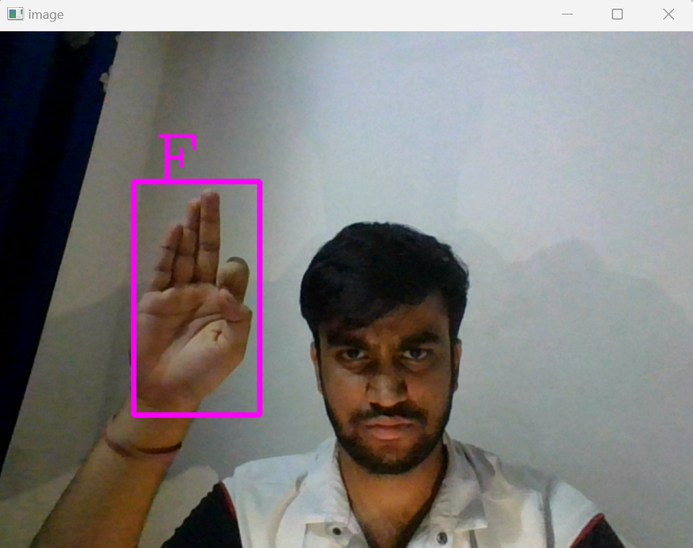

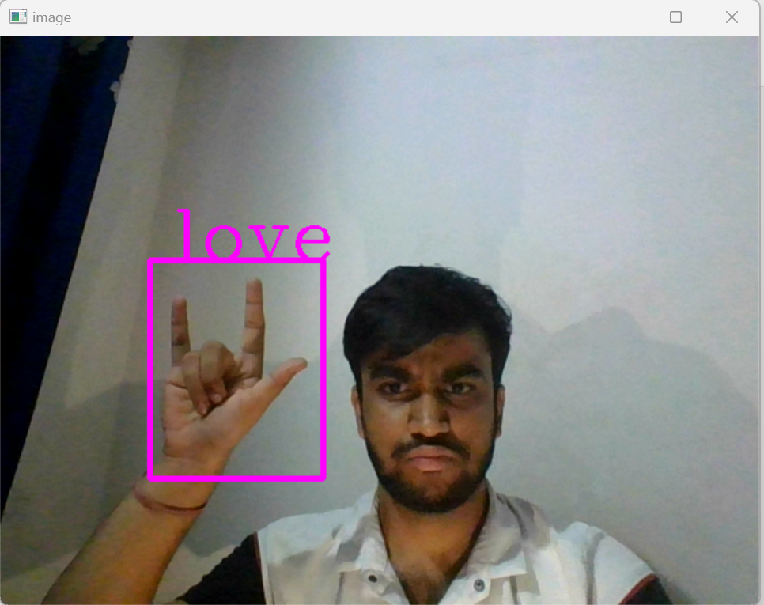 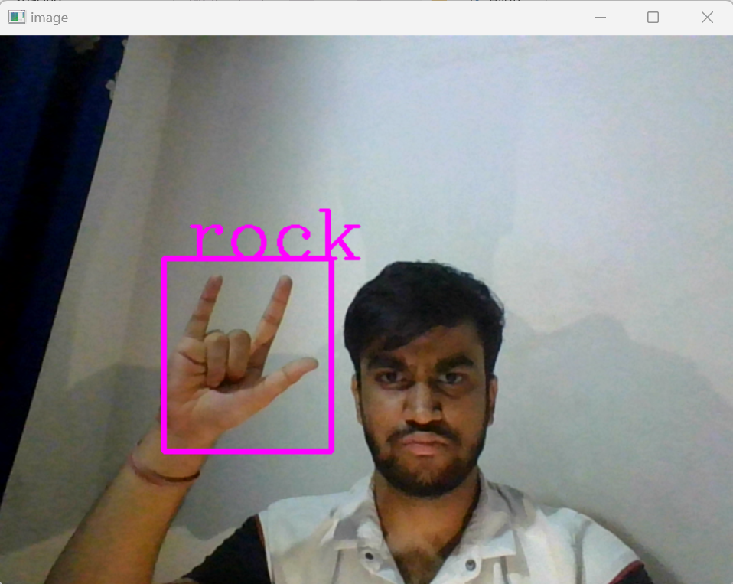 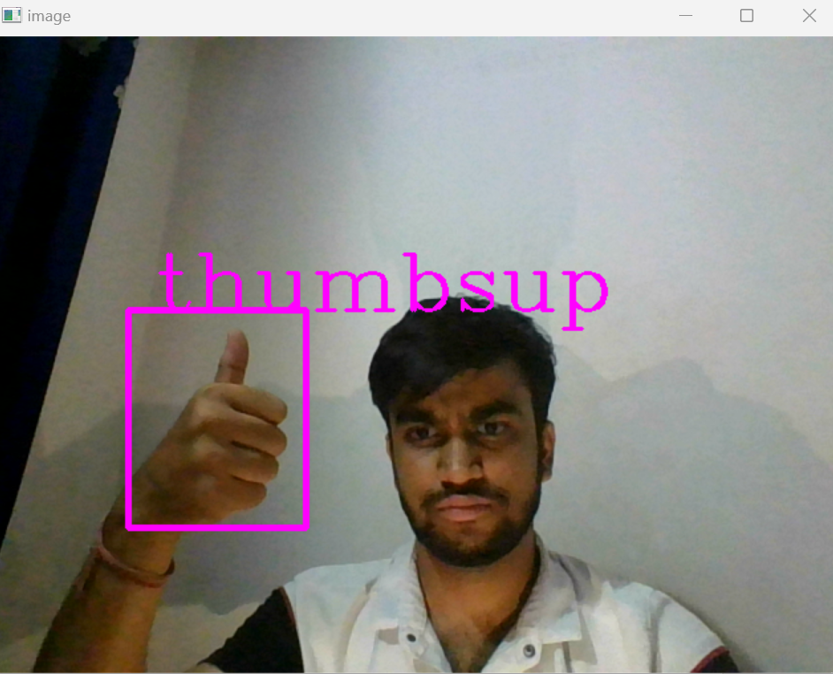

Hand gestures particularly alphabets and some general gestures are recognized with a good accuracy rate keeping in mind the small and custom-built dataset.

* In this system any user can provide data to input.
* The accessibility or response time of the applicationis fast and performance of the system is appropriate
* System can produce results faster on 4GB of RAM.
* Reduce hardware cost by eliminating use of mouse.
* Helpful for deaf people to communicate with others.
* **Chapter 5**

**Conclusion and Future Work**

The sign language recognition system can be expanded to recognize not only sign language letters but also gestures and facial expressions. Instead of just displaying letter labels, the system can provide more accurate translations of sign language sentences, making it easier to understand. The system can also be adapted to recognize different sign languages by incorporating more training data. Additionally, the project can be extended to convert symbols into spoken language, enabling speech output based on the recognized signs.

The sign language recognition system is a valuable tool that combines expert knowledge, edge detection, and information from various sources to achieve accurate classification. Convolutional neural networks are specifically designed to ensure the appropriate classification is obtained in this system.

The Proposed system can be further enhanced to recognize body gestures , dynamic motion detection of eyes and recognizing eye gestures , recognizing dynamic motion of body movements in patients and classifying the deformitites and disabilities.

**References**

[1] International Journal for Research in Applied Science & Engineering Technology (IJRASET) ISSN: 2321-9653; IC Value: 45.98; SJ Impact Factor: 7.177 Volume 8 Issue II Feb 2020- Available at www.ijraset.com

[2] Sourav Bhowmick, Sushant Kumar and Anurag Kumar, Hand Gesture Recognition of English Alphabets using Artificial Neural Network, published on 2015

[3] Onamon Pinsanoh, Yuttana Kitjaidure, Ariya Thongtawee. A Novel Feature Extraction for American Sign Language Recognition Using Webcam. Published in 2018.

[4][**https://github.com/cvzone/cvzone/tree/master**](https://github.com/cvzone/cvzone/tree/master)

[5] Razieh Rastgoo, Kourosh Kiani, Sergio Escalera,Sign Language Recognition: A Deep Survey, Expert Systems with Applications,Volume 164,2021,113794,ISSN 0957-4174,https://doi.org/10.1016/j.eswa.2020.113794.(<https://www.sciencedirect.com/science/article/pii/S095741742030614X>) Abstract: Sign language, as a different form of the communication language.

[6]Bloghttps://viso.ai/computervision/mediapipe/#:~:text=MediaPipe%20is%20an%20open%2Dsource,currently%20in%20alpha%20at%20v0.

[7] <https://teachablemachine.withgoogle.com/train/image>